Ansible Task 02
- Watch ansible-02 video and write down notes.
  - Ansible is an open-source automation tool used for configuration management, application deployment, and orchestration.
  - It is agentless, meaning no software needs to be installed on managed nodes. Communication happens using SSH.
  - Ansible uses playbooks, which are written in YAML format.
  - A playbook contains plays, and each play consists of tasks.
  - Tasks execute modules such as apt, service, copy, file, etc.
  - Inventory is a file that contains the list of managed hosts (nodes).
  - Handlers are special tasks that execute only when notified.
  - Notify is used to trigger handlers, mostly for restarting services.
Ansible makes automation simple, readable, and repeatable.

- Install httpd using ansible playbook, use handlers,notifiers.
Apache is a web server used to host web applications.
Using Ansible, Apache can be installed and managed automatically on Ubuntu servers.
Handlers are used to restart the Apache service whenever changes occur.
Step1:
Create playbook directory
- mkdir playbook
- cd playbook
- vi httpd.yml
Now write code to execute
Playbook: httpd.yml
- name: Install Apache on Ubuntu
hosts: all
become: yes

tasks:
- name: Install apache2 package
apt:
name: apache2
state: present
update_cache: yes
notify: restart apache

- name: Start and enable apache service
service:
name: apache2
state: started
enabled: yes

handlers:
- name: restart apache
service:
name: apache2
state: restarted

- Create playbook
vi httpd.yml
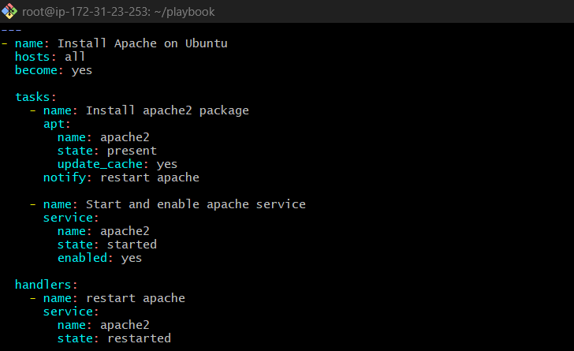
Save and Exit

After that we need to check the playbook syntax
- ansible-playbook httpd.yml –syntax-check

After that we will do a Dry Run, using below command
- ansible-playbook httpd.yml –check
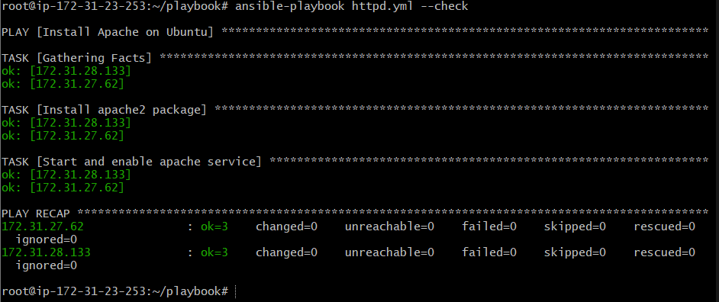
Execute playbook
- ansible-playbook httpd.yml
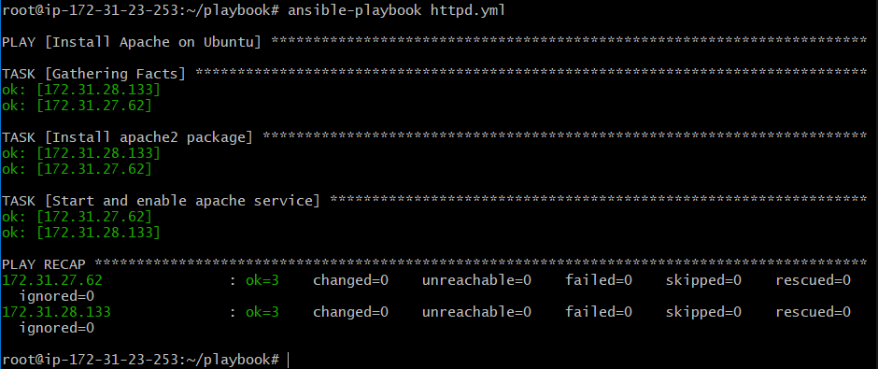

Verify service on both Workers
- systemctl status apache2
Worker-01
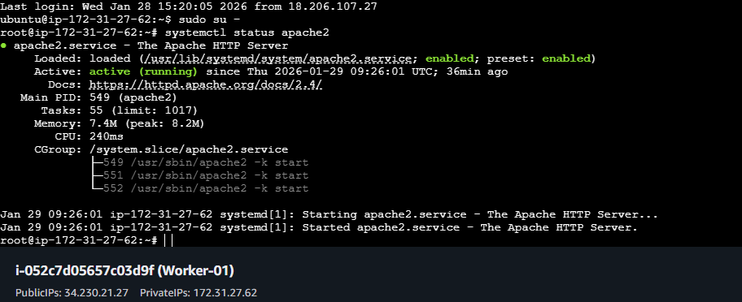

Verify: http://34.230.21.27/
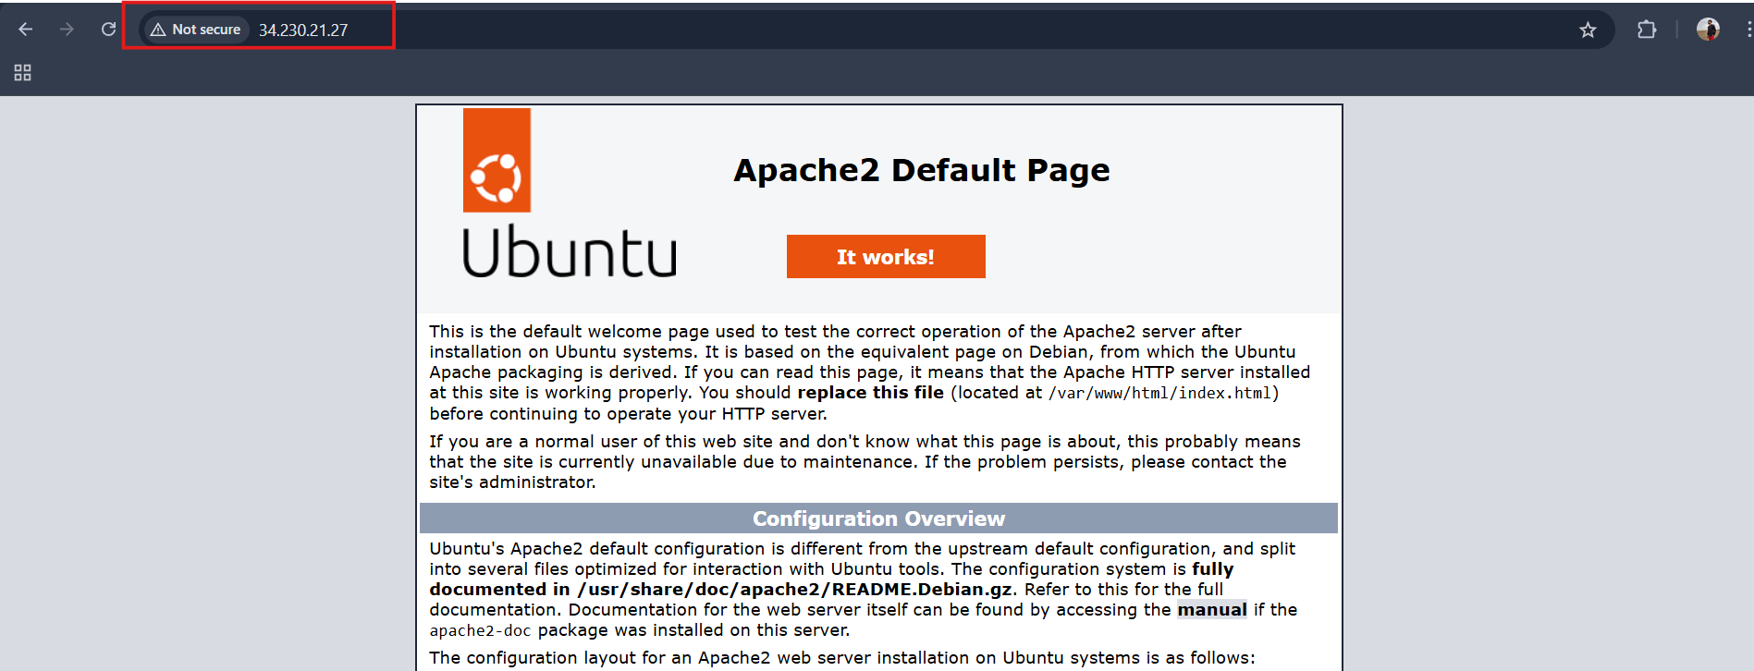

Worker-02
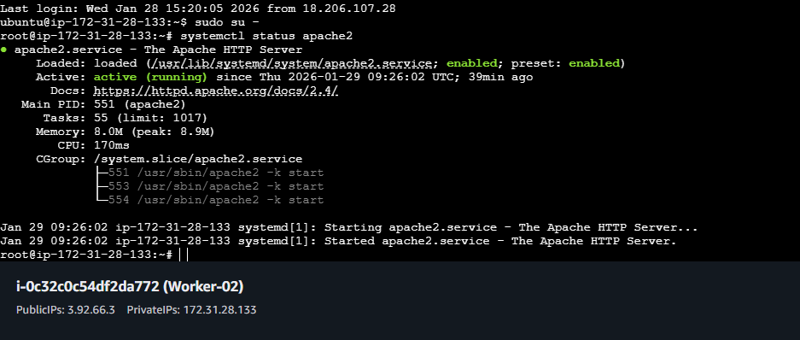

Verify: http://3.92.66.3/
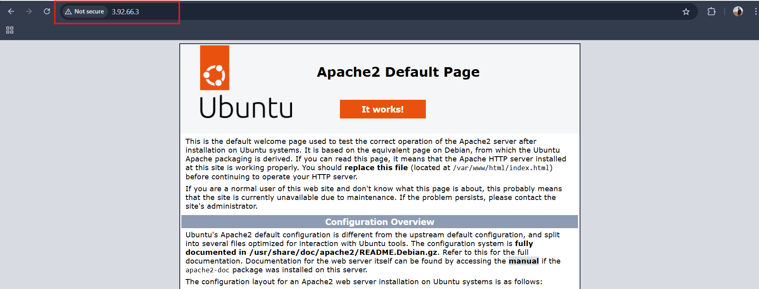

- Write an ansible playbook to install apache tomcat.
Apache Tomcat is a Java-based application server.
Java must be installed before installing Tomcat.
Ansible automates downloading and extracting Tomcat on Ubuntu servers.
Playbook: tomcat.yml
- hosts: all
become: yes

tasks:
- name: Install Java
apt:
name: openjdk-11-jdk
state: present
update_cache: yes

- name: Download and extract Tomcat
unarchive:
src: https://archive.apache.org/dist/tomcat/tomcat-9/v9.0.85/bin/apache-tomcat-9.0.85.tar.gz
dest: /opt
remote_src: yes

- name: Start Tomcat
shell: |
export JAVA_HOME=/usr/lib/jvm/java-11-openjdk-amd64
/opt/apache-tomcat-9.0.85/bin/startup.sh
args:
creates: /opt/apache-tomcat-9.0.85/logs/catalina.out
- Create playbook
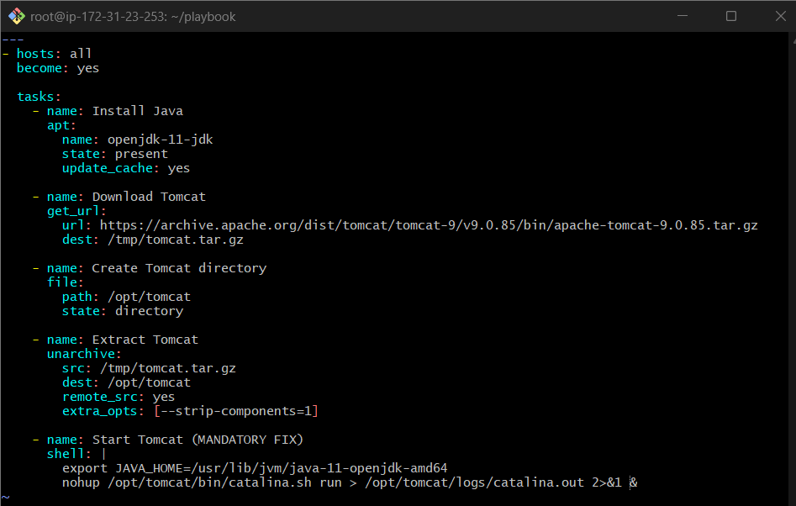
Save and Exit

After that we need to check the playbook syntax
- ansible-playbook tomcat.yml –syntax-check

After that we will do a Dry Run, using below command
- ansible-playbook tomcat.yml –check

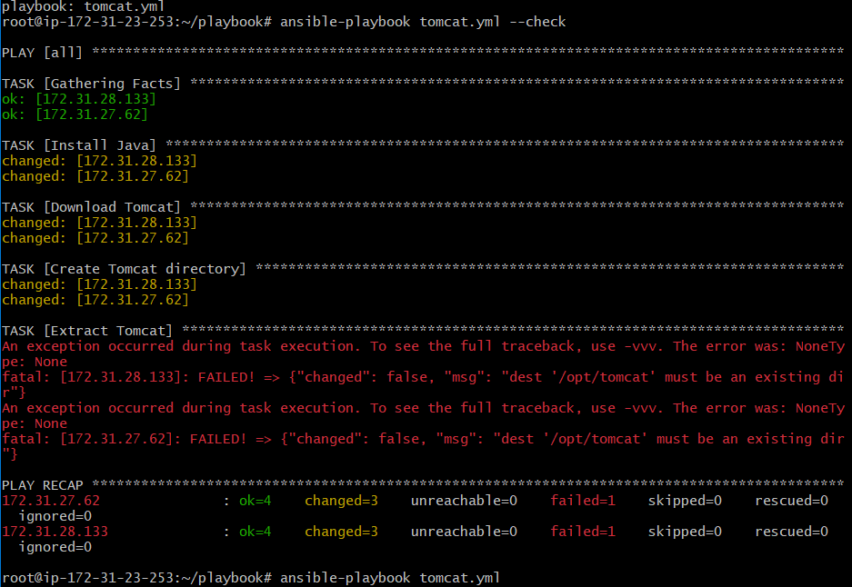

The error we r seeing bcoz we r running a dry run which means it is based on assumption that is the reason we r seeing this error
Once we run this tomcat.yml file then it will get executed and we can see that the tomcat is downloaded and is accessable on browser with <public-ip>

- Run playbook
- ansible-playbook tomcat.yml
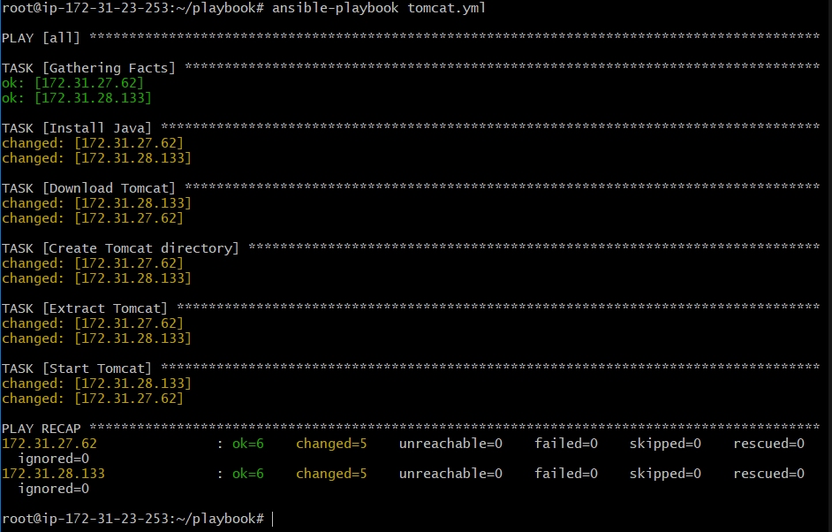

- Verify installation on both the workers

Worker-01
ls /opt/
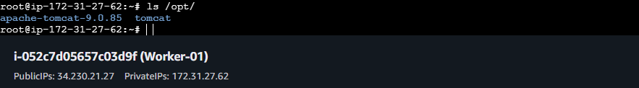
Verify: http://34.230.21.27:8080/
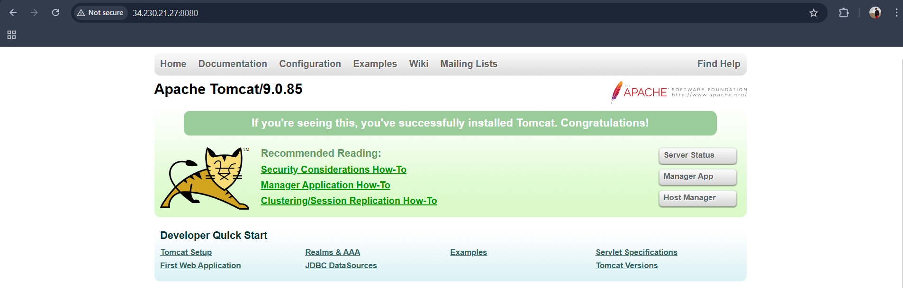

Worker-01
ls /opt/
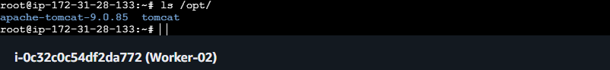

Verify: http://3.92.66.3:8080/
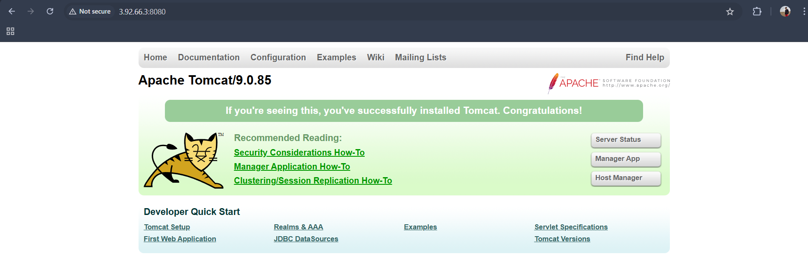

4. Write an ansible playbook to provision one ec2 on aws.
Ansible can be used to provision AWS EC2 instances using the ec2 module.
The control node must have AWS credentials and boto installed.
Playbook: ec2.yml
---
- hosts: all
connection: local
gather_facts: no

tasks:
- name: Create EC2 instance
amazon.aws.ec2_instance:
name: demo-server
region: us-east-1
instance_type: t2.micro
image_id: ami-0c02fb55956c7d316
key_name: ansible
security_group: default
wait: yes

- AWS credentials configured

Install required tools
apt update
apt install unzip curl -y

Download AWS CLI v2
curl "https://awscli.amazonaws.com/awscli-exe-linux-x86_64.zip" -o awscliv2.zip

Install
unzip awscliv2.zip
./aws/install

Verify
aws --version

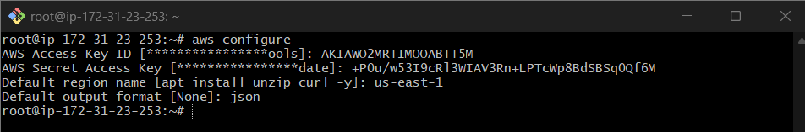
- Execute playbook
- cd playbook
- vi ec2.yml
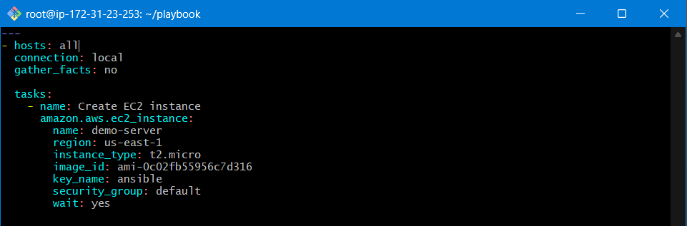
Save and Exit

After that we need to check the playbook syntax
- ansible-playbook ec2.yml –syntax-check

After that we will do a Dry Run, using below command
- ansible-playbook ec2.yml –check
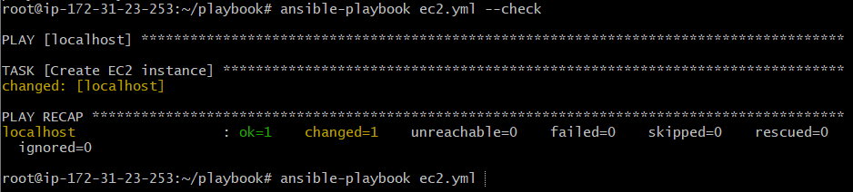

To launch the ec2 instance execute below command
- ansible-playbook ec2.yml
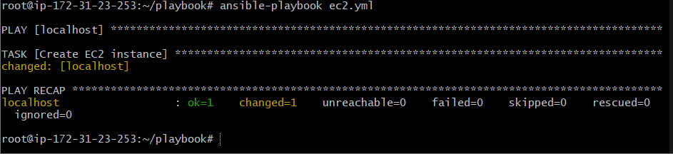

- Verify in AWS Console
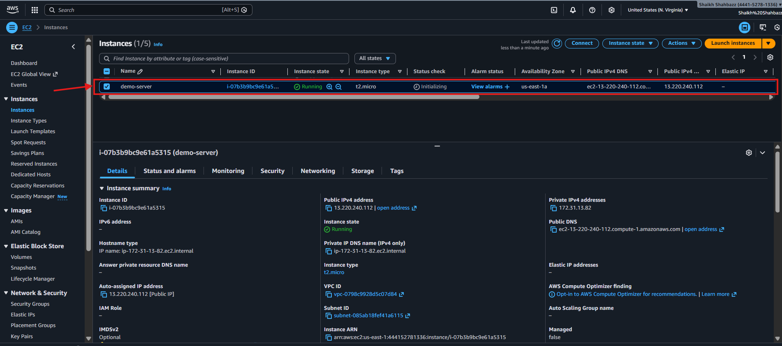

- Write an ansible playbook to copy one file from node-1 to node-2.
Ansible allows file transfer between nodes using delegation.
The delegate_to keyword executes tasks on another host.
First we need to create one file on worker01, so that we can able to copy that file in worker02
To create one dummy file on worker01 run below command from Controller
- ansible worker01 -m shell -a "echo 'Hello from worker01' > /tmp/test.txt"
Playbook
- hosts: worker01
become: yes

tasks:
- name: Fetch file from worker01
fetch:
src: /tmp/test.txt
dest: /tmp/test.txt
flat: yes

- hosts: worker02
become: yes

tasks:
- name: Copy file to worker02
copy:
src: /tmp/test.txt
dest: /tmp/test.txt

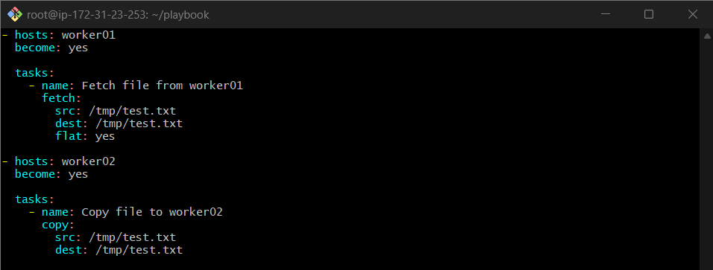

Save and Exit

After that we need to check the playbook syntax
- ansible-playbook copy.yml –syntax-check

- Verify file on node-1
> ls /tmp/test.txt

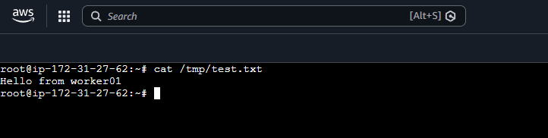

- Execute playbook
ansible-playbook copy.yml
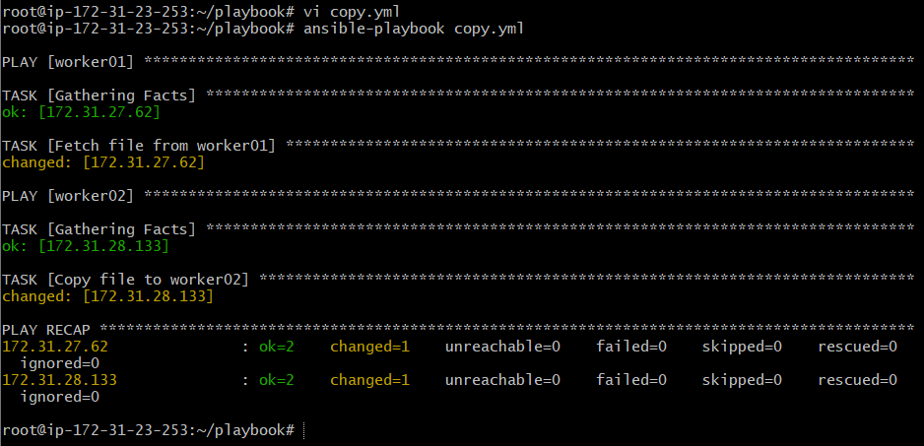
- Verify on node-2
ls /tmp/test.txt
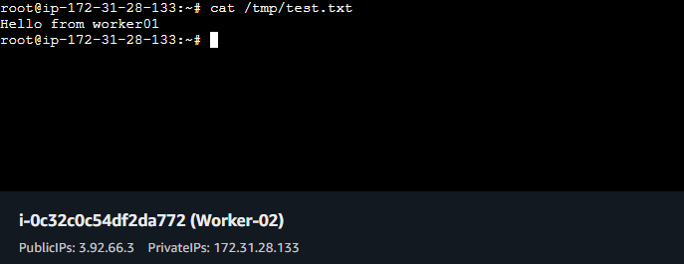

- Write an ansible playbook to create different files with different names using single playbook.
Ansible loops allow performing repetitive tasks efficiently.
Using a single playbook, multiple files with different names can be created.
Playbook
- name: Create multiple files
hosts: all
become: yes

vars:
files:
- dev.txt
- test.txt
- prod.log

tasks:
- name: Create files
file:
path: /root/{{ item }}
state: touch
loop: "{{ files }}"

- Create playbook
vi create_files.yml
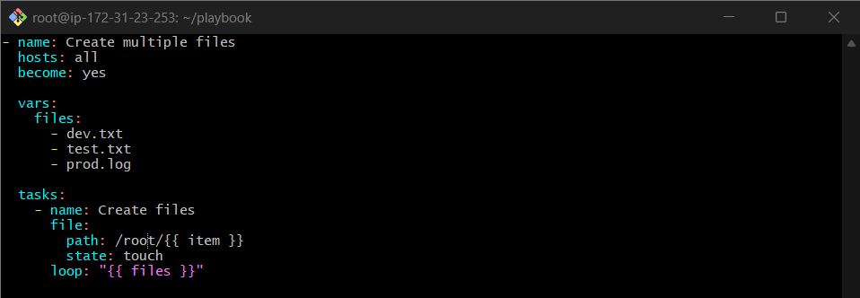

- Execute playbook
> ansible-playbook create_files.yml
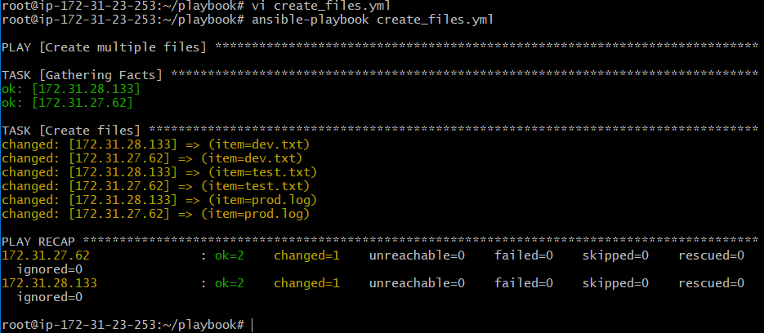

- Verify files on Workers
ls /tmp/
files created
Worker01
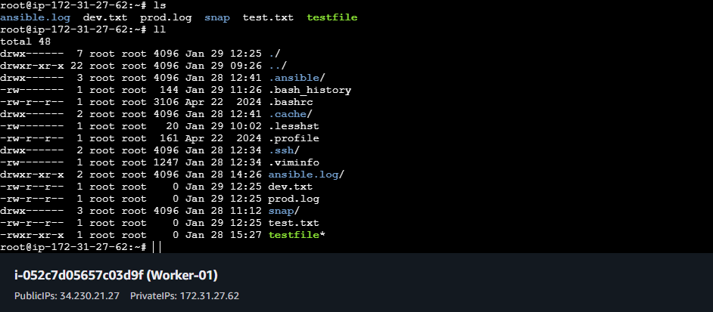

Worker02
